ID5 Annual Meeting in Japan

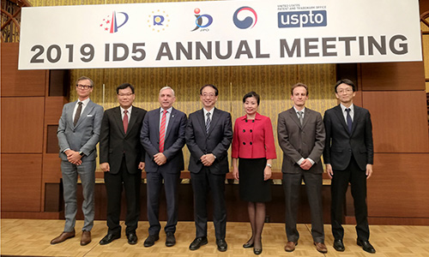

The Japan Patent Office (JPO) hosted the 5th Annual Meeting in Chiba, Japan, on 12-13 December 2019.

The EUIPO’s Executive Director, Christian Archambeau, participated in the meeting, which involved discussions on the ID5 partners’ respective projects.

[ID5](http://id-five.org/) is the multilateral cooperation forum, inaugurated in 2015, which allows the five largest offices dealing with industrial design, the China National Intellectual Property Administration (CNIPA), the Japan Patent Office (JPO), the Korean Intellectual Property Office (KIPO), the United States Patent and Trademark Office (USPTO) and the European Union Intellectual Property Office (EUIPO), to seek cooperation synergies for the benefit of users in the field of design registration.

The JPO also hosted an Experts’ Meeting on 13 December which focused on the expectations for **more efficient and user-friendly industrial design protection** to meet the needs of global users. The World Intellectual Property Organization (WIPO) was present as an observer.

During the meeting, the ID5 partner offices shared their **progress on a number of cooperation projects**. The EUIPO reported on the progress made in the two projects it leads, ‘Product Indications’ and ‘Forecasting’, as well as a project it co-leads with CNIPA on ‘Quality Management’.  The projects ‘Product Indications’ and ‘Forecasting’ were concluded and closed during the Annual Meeting.

The ID5 partner offices also gave an update on new projects that were adopted at the 2018 Annual Meeting, including ‘3D Printing’, ‘Admissibility of Internet Information as Legitimate Disclosure’, ‘Design Patent Quality Management’, ‘ID5 Recommended Design Practices’ and ‘Remedies for Design Patent Infringement’.  
  
A full day was dedicated to a **User Session**where the partner offices and user associations also focused on expectations for more efficient and user-friendly industrial design protection. The user associations LESI and UNION represented European users and were invited to play an active role in the session.

The EUIPO’s Executive Director, Christian Archambeau, congratulated JPO for the efforts made this year towards the organisation of the meeting. He also commended the partner offices for the remarkable cooperation efforts made during 2019.

The ID5 partners also agreed that the **USPTO would be the host and secretariat for the ID5 Fora in 2020.**

Updates on recent developments at the ID5 forum can be found through the [ID5 website](http://id-five.org/) and by subscribing to the news feed.